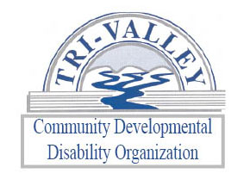
Affiliate Application
Instructions: Please complete the entire application. If you need additional space, please use the back of the application. If you have any questions, please contact the CDDO at (620)431-7796.
Name of Agency Requesting Affiliation:
Address:
City: |  |  |  |  |  |  |  |  |  | State: |  |  |  |  |  | Zip Code:
Telephone:
Fax:
Cell:
E-Mail Address:
Website:
Name of Executive Director/President:
Corporate Status: |  |  |  |  | For Profit |  |  | Not for Profit
Mission Statement:
What is your experience working with people with disabilities?
Are you willing to serve all persons regardless of the severity of each person’s disability?
What services are you planning to provide in each of the four counties in the CDDO catchment area?
What is the maximum number of persons you are able to serve?
Are you willing to abide by state regulations 30-63-1 thru 30-63-3 and 30-64-1 and 30-64-33?
Please initial the following regulations thus indicating that you understand the requirement.
- Background checks will be completed on all employees
- Reports, documentation, data will be furnished as requested by the CDDO
- Provide an annual audit.
- Billing shall be supported with documentation required by the CDDO
- Maintain driving record checks for all employees who transport clients
- There is a need for nursing oversight
- Staff will meet minimum training requirements
- Filing all state and federal reports; ex. Employment tax, social security, workman’s Comp, etc.
Documents Required:
- Business Plan
I, the undersigned, acknowledge that if my agency is approved as an affiliate of the Tri-Valley CDDO, that I will comply with all of the requirements as dictated in the contract agreement and agree to abide by state and federal regulations governing developmental disabilities services.
Authorized Representative |  |  |  |  |  |  |  |  |  |  |  |  |  |  | Date

